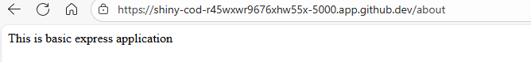



Today we learn about creating basic Express web application using Node.js.